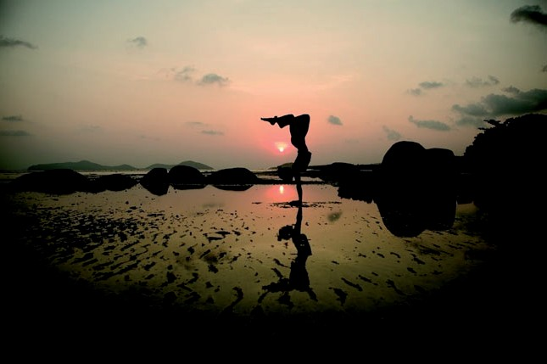

Yogful Journey

See the World differently.

To go on a yoga holiday or yoga retreat and explore different countries is always an enchanting and learning experience. Creative Yoga Retreat venues and Yogful/Esplorando Travel journeys blend the world of yoga and inner discovery with sensory experiences of visual beauty, healthy tastes, cultural enrichment, and outdoor adventure. Each destination is carefully selected for its serene beauty, nutritious food, and a magical element that opens hearts and minds and the can “see the world differently.” The natural surroundings and secluded setting create an atmosphere of calm and stillness, ideal for yoga and meditation retreats and holidays. Yogful/Esplorando Travel can offer its support and professional experience to all the guests to plan their trip to the retreat, to extend their journey through Italy and Europe, and to plan excursions to the most beautiful cities and natural landscapes.

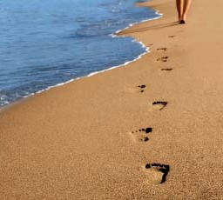

Meet our Team

Knowledgeable and extremely organized, our guides will become an essential part of your journey.

Cristina Villa is an Italian, Film, Literature, and Yoga Teacher and a massage therapist. She lived and worked in L.A. and she was trained there in yoga, Ayurveda , and massage therapy. Positivity, radiance, and respect are fundamentals for the world of yoga and for Cristina and she strives to spread them by organizing yoga retreats in the beautiful Italian countryside and cities .

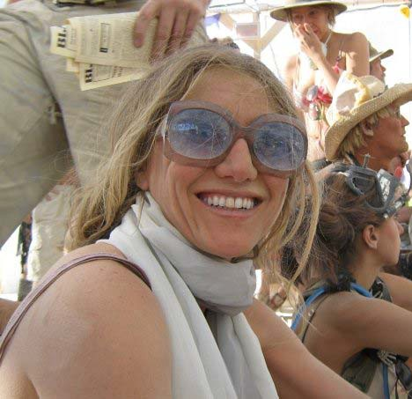

A travel experience with Esplorando Travel is a quest for inspiration, change, growth, education, and magic. We offer unforgettable moments in your lives, we accompany you in enchanting places, we share visions and fascinating images
with you.

Choose your Vision.

When you are travelling, it is important to understand your needs and expectations and respect yourself, choose a suitable accommodation for you. Our Choose Your Trip planner can help you planning your trip.

Green Vision

Feel comfortable and share tours and activities with other fellow travelers and stay in the city centre or in more peaceful areas right outside the center. Ask for more detailed information.

Yellow Vision

Explore and share tours and activities with other fellow travelers and stay right in the city centre to deeply experience our journey and enchanting locations.

Light Blue Vision

Travel with your friends and family or by yourself to be more connected to you and your close environment. We will organize private activities for you and you can stay in beautiful places at the hearth of fascinating cities or locations.

As Clear as the Air Above the Clouds.

Booking your flight is extremely important.

We will offer you our special fares for the best flights for your chosen itinerary. Airline prices are guaranteed only on the day you buy your ticket. With us, you can reserve your flight now and pay for it later and get the mileage credit offered by your frequent‐flyer club. Choose your seat when you make your reservation. If possible, we will reserve your preferred seat at the time of booking.

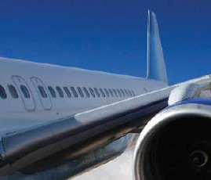

Our Tours.

We have been creating and organizing a variety of vacations, fully organized tours or independent vacation packages, for more than 20 years, encountering the travelers’ needs and offering them discoveries, adventures, and amazing experiences.

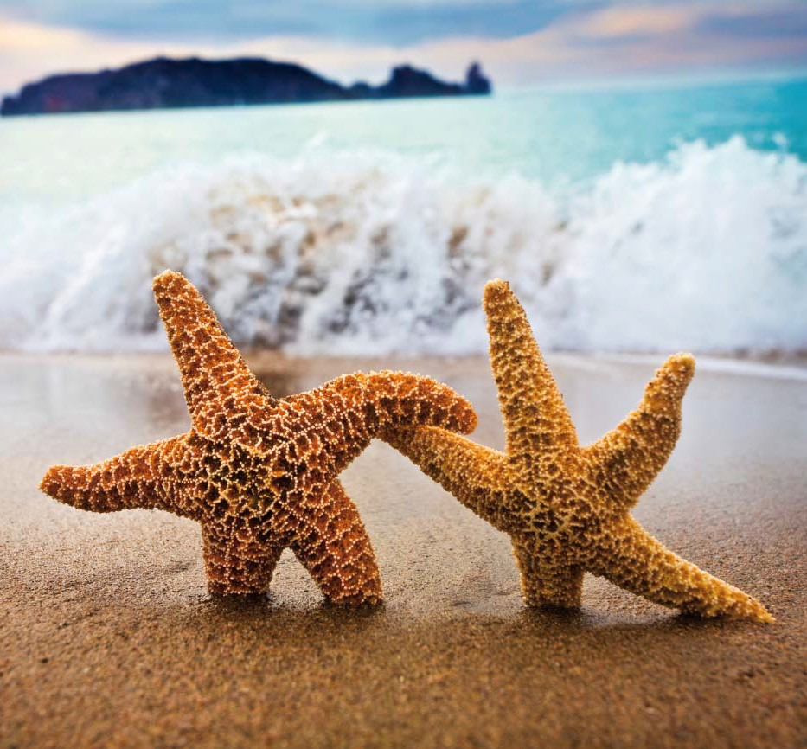

YOGA RETREAT EXPRESS

Itinerary

Day 1 – Day 7 : Yoga Retreat

At your arrival, you will meet our local guide and then you will be transferred to your yoga retreat location. A yoga retreat is the ideal experience to find peace, tranquility, and a deep contact with nature in a friendly atmosphere.

Day 7:

Depending on your departure flight you are privately transferred to the airport.

Toppings

Transfer to/ from Airport, Railway Station, and/or any other location in Italy and Europe. Rates on demand.

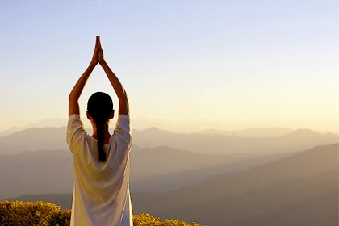

TASTE OF ITALY & YOGA RETREAT

Discover Italy through simple pleasures. Enjoy an al fresco lunch in a sidewalk trattoria. Wander through the narrow streets of Florence, admire Medieval and Renaissance architecture and art, and enjoy the fascinating life along the canals of Venice.

Itinerary Day 1: Venice
At your arrival at the Venice airport, you will meet our local guide and you will be transferred to your hotel for a four night stay. Explore Venice with your private guide starting at St. Mark’s Square. Visit the magnificent St. Mark’s Basilica, an 11th century dazzling blend of Western and Byzantine architecture. Continue to the Gothic Doge’s Palace and admire the ceiling in the Great Council Chamber, painted by Tintoretto. Afterwards enjoy your free time wandering through the small Venetian streets.

Day 2: Venice

Spend a half day exploring the market district around the Rialto Bridge. Since the 11th century, Venetians and foreign merchants have been trading imported exotic goods and this market is a Venetian trading center . At a bacari, a small wine bar, taste un’ ombra (a small glass of wine) with traditional Venetian snacks. At the nearby Frari church, admire the beautiful Madonna and Child by Giovanni Bellini and the Assumption of the Virgin by Titian.

Day 3: Venice/Florence

Our guide will walk you to the main railway station in Venice. You will take a fast intercity train to Florence, meet our guide at the railway station, and be transferred to your hotel. Our local guide will offer you a walking tour of this paradise for art lovers and birthplace of the Renaissance. Visit the great Duomo, the Cathedral, and the Uffizi Gallery with such striking works of art as Caravaggio’s Medusa, Botticelli’s Birth of Venus, Da Vinci’s Annunciation, Michelangelo’s The Doni Tondo, and Raphael’s Madonna of the Goldfinch. Later, head to Ponte Vecchio, the oldest and most famous bridge in Florence, where you can enjoy an amazing view.

Day 4: Florence

Head up hill to Piazzale Michelangelo for a marvelous view of the city and visit the 11th‐century church of San Miniato al Monte and admire its fine frescoes. Later, observe and be surprised by Michelangelo’s David at the Galleria dell’Accademia. Spend the rest of the day exploring the city by yourself and getting lost in its beauty.

Day 5: Florence/Rome

Transfer to the railway station, take a train to Rome and, in Rome,
meet our guide that will transfer you to your hotel. The Hotel is
at the heart of Rome and a few minutes away from the Spanish Steps,
Villa Borghese, the Trevi Fountain, and Via Condotti with
its fashionable boutiques. The rest of the day is free.

Day 6: Rome

Enjoy a free sightseeing day starting your morning in ancient Rome visiting the main square, example of Michelangelo´s architectural genius, the Roman Forum, Palatine Hill and the Coliseum. While walking along the ruins of the forum, you can see the temple of Vesta, the Arch of Titus and the Arch of Costantine. Afterwards, you can dedicate your day to the exploration of the baroque Rome with the Trevi Fountain, the Pantheon, which was originally a pagan temple, Piazza Navona and such fountains as the Fountain of the Four Rivers, a glorious baroque creation by 17th‐century sculptor Bernini. The rest of the day and evening are free and you can enjoy the art and beauty of Rome.

Day 7: Rome/Vatican/Rome

Another full day of free sightseeing starting with the Vatican and its museums, collections, galleries, papal palaces and Michelangelo’s Sistine Chapel. Then continue to St Peter’s Basilica which is the largest church in the world and a place of pilgrimage for thousands of people. The enormous dome soars above the altar, above the supposed tomb of Saint Peter. Then we venture into Christian Rome starting in Piazza San Bernardo, crossing Piazza della Repubblica and Via Nazionale to the Basilica of St Mary Major, Basilica of St John in Lateran and the Holy Stairs, climbed by Jesus Christ to reach Pilate’s Palace. From here we board our coach, passing Piazza San Giovanni, Via Latina, Mura Latine, Porta di San Sebastiano and onto the Ancient AppianWay with its “Domine Quo Vadis” chapel, finally arriving at the Catacombs of St Callixtus. We then return to the hotel where the rest of the day and evening are free for you to enjoy.

Day 8: Rome /Yoga Retreat

Meet our guide for a transfer to Yoga retreat. On arrival, we’ll meet our local guide and then transfer to Hotel for your stay.

Day 9 – Day 14 : Yoga Retreat

It is the ideal spot for anyone seeking peace, tranquillity and contact with nature in a friendly family atmosphere. Overnights

Day 15:

Another day of Yoga. Depending on your departure flight you are privately transferred to the airport, where you board.

SICILY & YOGA RETREAT

Mediterranean island Sicily is an intriguing blend of European style, history and exotic flare. Located between mainland Italy and Tunisia, Italy's largest island is blessed with a beautiful climate, breathtaking scenery and incredible sights that chronicle Mediterranean history and culture over the centuries. Sicily's unique culture is complemented by stunning natural beauty ‐ rolling valleys swathed in olive trees and vineyards, spectacular views of Mount Etna, and over 1,000 miles of pristine coastline surrounded by exotic islands. All this makes Sicily the perfect destination for a relaxing beach holiday with incredible sightseeing.

Itinerary

Day 1: Catania/Riviera dei Ciclopi

Arrival at Catania airport and meet the guide for transfer to the hotel booked in the Riviera dei Ciclopi. Accommodation and time at your disposal.

Day 2: Piazza Armerina/Cefalu/Palermo

Departure to Piazza Armerina, in the heart of Sicily, known as “il granaio/granary di Roma” in the Roman époque and visit to Villa del Casale, famous for its mosaics. In the afternoon departure to Cefalu’ to visit to ancient Cathedral, one of the most beautiful Sicilian church of the Norman period. Departure to Palermo. Arrival and accommodation at the hotel.

Day 3: Palermo/Monreale

Morning dedicated to site inspection of the city. In the capital of island we underline/suggest: the Cathedral, Palazzo Reale with the precious Cappella Palatina, the historical center with I Quattro Canti, Teatro Massimo, Piazza Pretoria with its fountain. Departure to Monreale for a visit the Chiostro of Norman Cathedral.

Day 4: Erice and Selinunte/Agrigento

After breakfast departure to visit the Medieval village of Erice and the archeological park of the ancient Greek City of Selinunte. In the afternoon departure to Agrigento. Arrival, transfer to the hotel and accommodation in the room. Time at your disposal and dinner at the hotel. During the evening opportunity to enjoy the beautiful sight of lighted Valle dei Templi. Overnight at the hotel.

Day 5: Agrigento/Caltagirone/Riviera dei Ciclopi

Breakfast at the hotel, then visit to Valle dei Templi with some of the most beautiful temples such as: Hera , Concordia, Hercules and Giove. Then we continue for Caltagirone and visit of this city famous thanks to its ceramics. In Caltagirone we can admire the marvelous stairs of Santa Maria del Monte with its 142 steps in majolica and we will visit a traditional shop of a maestro pottery. Lunch on the road. Transfer to Riviera dei Ciclopi and accommodation at the hotel.

Day 6: Etna/Taormina/Riviera dei Ciclopi

After breakfast departure to Etna, the highest active volcano in Europe,
3.370 meters high. We will arrive to 2000 meters high in order to enjoy a beautiful view over the island. Lunch on the way, then transfer to Taormina
where you have time available to discover characteristic corners or its
monument such as the Duomo or the Greek‐Roman theatre, or walking around for shopping or just relax having a drink or tasting typical specialty of the area.

Day 7: Riviera dei Ciclopi/Catania/ Yoga Retreat

Meet our guide for a transfer to Yoga retreat. On arrival, we’ll meet our local guide and then transfer to Hotel for your stay.

Day 9 – Day 14 : Yoga Retreat

It is the ideal spot for anyone seeking peace, tranquillity and contact with nature in a friendly family atmosphere. Overnights

Day 15:

Another day of Yoga. Depending on your departure flight you are privately transferred to the airport, where you board.

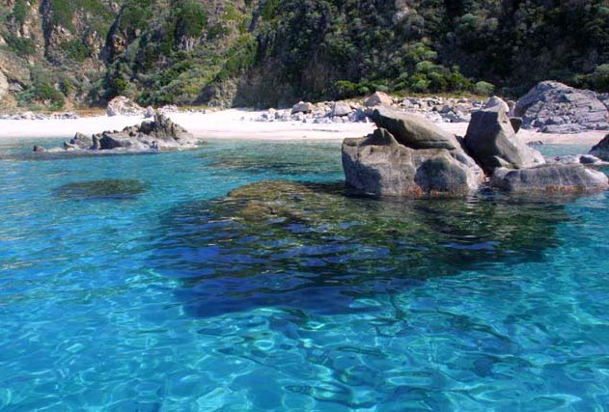

NOLITA North Little Italy & YOGA RETREAT

Explore the picturesque northwest regions of Italy, from tranquil Lake Como and its mountainous backdrop to the fishing villages outside Genoa to the steep, rugged cliffs of Cinque Terre; wherever you look, the scenery is unrivaled. On this independent journey, discover terraced vineyards, sample famous truffles and visit villages still firmly attached to their old customs and traditions.

Itinerary

Day 1 Milan

Arrive in Milan and transfer to your hotel . Milan includes a half day sightseeing tour of the city’s highlights. Fashion is big business and a big draw in Milan, from the extremely upscale stores of the Quadrilatero d'Oro to there's plenty of other things to see and do including the ornate Duomo cathedral, the famous La Scala opera house, Naviglio Grande, Darsena, Conca di Viarenna, San Lorenzo Basilica and Columns, St Aquilino Chapel as well as the art museums, galleries and elegant palazzos. Leonardo da Vinci aficionados can book a viewing of “The Last Supper” and visit the Museo Nazionale della Scienza e Tecnica to see da Vinci's technical drawings and models. There is a very wide choice of restaurants, bistros and cafes to choose from as well as live music, opera and theatre. Make the most of it.

Day 2 Como Lake
Travel by car from Milan and arrive on the shores of Lake Como. Embark on a private boat trip on Lake Como, stopping to visit Villa del Balbianello, resting
on a hill overlooking the lake. A Month on the Lake, as well as some scenes
from the later Star Wars movies, were filmed here. Travel to the jewel in the crown of Italy's lakes, the resplendent Lake Como. This enchanting lake is most famous amongst the elite and its romanticism can be seen in the surrounding grandiose snow‐capped mountains, the sublime cuisine, Italian lifestyle and glorious sense of tranquility. Lake Como is renowned for great sailing, windsurfing and kite surfing and is the most charming of places to charter a luxury yacht. It is also renowned for its palatial villas, the most famous being Villa Carlotta home to a great art collection and magnificent interior. The most glorious thing to do when at Lake Como, is to find a café, sip a latte and watch the stylish world go by.

Day 3 Alba

From Como Lake depart with your Travel Guru, to visit Alba, famous for its vineyards and truffles, and in Barolo, see Grinzane Cavour castle. After have a delicious lunch, procede your travel to Turin

Day 4 Turin

In the Piemonte region, visit Turin with your private guide, this year celebrating its 150th anniversary as the first capital of the modern Italian Republic.

Day 5 Portofino

Depart from Turin , stop in Genoa and the lovely fishing towns of Bogliasco, Recco and Camogli en route to Portofino, one of Italy’s most romantic locations. Discover Portofino’s rugged coastline, dotted with pastel‐coloured houses and a harbour of luxurious yachts. This glamorous and exclusive seaside resort is a haven for jet‐setters and stars, and also boasts historic landmarks such as Castello Brown and the 14th‐century Abbazia della Cervara, once home to Benedictine and French Trappist monks. Laid‐back Rapallo is set among orange groves, with a thriving harbour and 16th‐ century castle that once protected the city from pirates.

Day 6 Cinque Terre

Cinque Terre (“Five Lands”) is built along the steep coastal cliff s of Liguria, and at one time its vineyards and fishing villages were only accessible by sea. Today, the local people still remain strongly attached to their old customs and traditions. Visit Vernazza, a beautiful village consisting of tall and colorful houses; Manarola, a fishing village set amid terraced vineyards; and Rio Maggiore, a medieval village set in a narrow valley with an interesting backdrop consisting of the strange black rock strata of this region.

Day 7 Cinque Terre/ Yoga Retreat

Meet our guide for a transfer to Yoga retreat. On arrival, we’ll meet our local guide and then transfer to Hotel for your stay.

Day 9 – Day 14 : Yoga Retreat

It is the ideal spot for anyone seeking peace, tranquillity and contact with nature in a friendly family atmosphere. Overnights

Day 15:

Another day of Yoga. Depending on your departure flight you are privately transferred to the airport, where you board.

LONDON & PARIS & YOGA RETREAT

Visit many of the iconic sights in London and Paris, from the Tower of London and Trafalgar Square to the Arc de Triomphe and the Louvre. Ride a car high up on the London Eye and peer out over the Thames to see magnificent Westminster and the City of London. Journey to Paris in comfort and style aboard the Eurostar, travelling under the English Channel. Then travel to Versailles for a look at the opulent palace of Louis XIV.

Itinerary

Days 1: London, England

Fly t to London where you are met by your Travel Guru and transferred by private vehicle to your centrally located hotel. The remainder of today is at leisure.

Day 2: London

Meet your expert local guide and chauffeur for a day of private sightseeing in London. See the famous Beefeaters guarding the Crown Jewels at the Tower of London. Stand on the Tower Bridge for excellent views of the Thames and the City of Westminster. Nearby is St. Paul’s Cathedral, rebuilt by Sir Christopher Wren after the Great Fire of London in 1666. This afternoon, take a ride on the London Eye. As you are carried to the top of this modern‐day Ferris wheel, you enjoy a spectacular view over the city. Continue to Trafalgar Square, where the National Gallery of Art is overshadowed by Nelson’s Column that rises up from the fountain. Then head down Whitehall and past Downing Street to the Houses of Parliament and Westminster Abbey, the site of many state occasions, including coronations and the wedding of Prince Charles to Lady Diana. Pass Buckingham Palace, the Queen’s official residence in London, on the way back to your hotel.

Day 3: London/Windsor Castle /London

Today, venture out to Windsor, outside London, for a tour of Windsor Castle, the largest inhabited castle in the world and the Queen’s favorite residence. Subject to opening restrictions, you may view the State Apartments, St. George’s Chapel and Queen Mary’s Doll’s House. From the castle ramparts you can see Eton College, the boarding school attended by Prince William and Prince Harry. The school was founded in 1440 by Henry VI. Visit the old town to peruse some of the boutiques and cafes.

Day 4: London/Paris, France

Tranfser to St. Pancras station with your guide, who assists you in boarding the Eurostar for your journey to Paris via the “Chunnel.” In Paris, the “City of Light,” your French Travel Guru meets you on the platform and assists with your transfer by private vehicle to your hotel.

Day 5: Paris

In Paris, even the buildings are works of art. View many of these iconic sights on your morning overview tour: the Eiffel Tower; Arc de Triomphe; Champs‐ Élysées; Sainte Chapelle, a pearl of Gothic architecture; and Notre Dame Cathedral on Ile de la Cité. Discover the treasures in the world‐famous Louvre Museum this afternoon. Enter the courtyard to see I. M. Pei’s glass pyramid that adds a contemporary touch to this enormous complex. Once the former royal residence of the Kings of France, the sprawling Louvre palace contains one of the most important art collections in the western world, spanning from antiquity to the mid‐19th century. Its best‐known works include the Mona Lisa and Venus de Milo. Afterward, take a scenic cruise on the River Seine for a different view of this amazing city.

Day 6: Paris/Versailles/Paris

Many rulers, including Peter the Great of Russia, have tried to outdo the magnificence of the “Sun King” Louis XIV’s Château of Versailles, a UNESCO World Heritage Site. Originally a humble hunting lodge for Louis XIII, Versailles was expanded by Louis XIV and transformed into one of the most impressive works of 18th‐century French art. In 1682 he moved the court and government of France there, and Versailles served as the seat of French government until the 1789 French Revolution. Admire the stunning palace and visit its State Apartments and decorative gardens.

Day 7: Paris/Yoga Retreat

Meet our guide for a transfer to Yoga retreat. On arrival, we’ll meet our local guide and then transfer to Hotel for your stay.

Day 9 – Day 14 : Yoga Retreat

It is the ideal spot for anyone seeking peace, tranquillity and contact with nature in a friendly family atmosphere. Overnights

Day 15:

Another day of Yoga. Depending on your departure flight you are privately transferred to the airport, where you board.

Our Extensions.

Pre or Post­Trip

You can tailor make your tour so it’s unique to you, making sure you get the most out of your intrepid exploration. Add an extension on demand and choose your day of departure, hotel, meal plan and flight class. In some cases you can even add excursion packages.

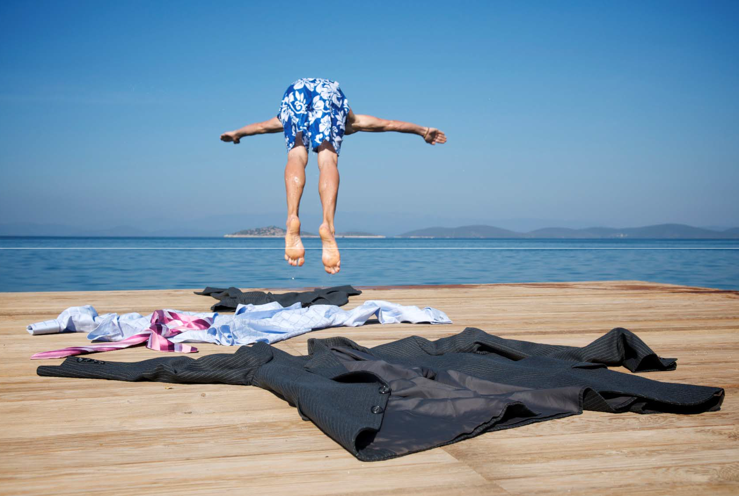

EXTENSION ROME

Itinerary Day 1: Rome

On arrival, we’ll meet our local guide and then transfer to Hotel for your three night stay. This luxury hotel is centrally situated and is minutes away from the Spanish Steps, Villa Borghese, Trevi Fountain, and Via Condotti with its fashionable boutiques. The rest of the day is free for you to relax.

Day 2: Rome

Enjoy a full sightseeing day starting a morning in ancient Rome in which you will see the main square, the result of Michelangelo´s architectural genius, from where you can see the Roman Forum, Palatine Hill and the Coliseum.Walking along the forum’s ruins, you can see the temple of Vesta, the Arch of Titus and the Arch of Costantine. Then we begin to explore baroque Rome with a visit to the Trevi Fountain, the Pantheon which was originally a pagan temple, Piazza Navona and its fountains including the Fountain of the Four Rivers in the centre of the piazza, a glorious baroque creation by 17th‐century sculptor Bernini. Rest of the day and evening are free for you to enjoy.

Day 3: Rome/Vatican/Rome

Another full day of sightseeing starting with the Vatican and its museums, collections, galleries, papal palaces and Michelangelo’s Sistine Chapel. Then continue to St Peter’s Basilica which is the largest church in the world and a place of pilgrimage for thousands of people. The enormous dome soars above the altar, above the supposed tomb of Saint Peter. Then we venture into Christian Rome starting in Piazza San Bernardo, crossing Piazza della Repubblica and Via Nazionale to the Basilica of St Mary Major, Basilica of St John in Lateran and the Holy Stairs, climbed by Jesus Christ to reach Pilate’s Palace. From here we board our coach, passing Piazza San Giovanni, Via Latina, Mura Latine, Porta di San Sebastiano and onto the Ancient AppianWay with its “Domine Quo Vadis” chapel, finally arriving at the Catacombs of St Callixtus. We then return to the hotel where the rest of the day and evening are free for you to enjoy.

Day 4: Rome

You are privately transferred to the airport, where you board your departure flight.

EXTENSION VENICE

Itinerary Day 1: Venice
On arrival in Venice, your local guide will meet you and take you by private transfer to your hotel, for your three night stay. When you leave the bustling street and come into the hotel through its revolving doors, there’s a timeless and peaceful world of luxury and sophistication in the large, comfortable entrance hall. The rest of the day is free and evening are free for you to relax and enjoy the comforts of your luxury hotel.

Day 2: Venice

Today there is a half day walking tour of Venice taking in all the key historical sites including the Basilica San Marco, Palazzo Ducale, Bell Tower, Procurate, Santa Maria Formosa, The Pantheon of Venice and the bustling Rialto Bridge and Rialto market. You will also visit the Golden Basilica, one of the most majestic cathedrals in the world and witness the masterpiece of Byzantine art. Visit Doges’s Palace, the city’s most famous building, which rises out of the water. The most impressive secular building in Venice, this palace represented Venetian political power for centuries, serving as the senate house, administrative centre, hall of justice, public archive and prison up until the fall of the Venetian Republic in 1797. Venice's main water thoroughfare, lined with great Renaissance palaces, is a colourful and busy spectacle of gondolas and vaporetti. Although it’s tempting to keep walking, be sure to stop at the occasional cafe and simply watch Venetian life in front of your eyes.

Day 3: Venice

Today is a completely free day for you to do whatever you would like, whether that be exploring further to see some of the other parts of the city, returning for a second look to one of the sites that you particularly enjoyed or simply relaxing and enjoy the many facilities of your hotel. How about a visit to the nearby island of Murano which is famous for its distinctive glass works. Or why not take to the waters with a gondola or vaporetto ride and see things from a different perspective? The great thing about Venice is that there is always a great choice of things to do and see, no matter what your specific interests are and no matter how relaxed or energetic you want to be. You can take in the classic and popular tourist attractions, but there’s also something quite exciting about meandering through the streets and finding your own little gem – a delightful family run bistro, a little art gallery displaying work from local artists or a beautiful shop with the perfect gift to take back to family or friends. Enjoy your final night in Venice – there’s a great deal of restaurants, bistros and cafes for you to choose from.

Day 4: Venice

Make the most of your final day in Venice. Your return flight is conveniently planned

EXTENSION CAPRI

Unquestionably, the islands in the Bay of Naples, Capri is the holiday princess of the Italian islands. Idyllic, rugged Capri, the palace island of the Emperor Tiberius, exudes an air of exclusivity and glamour. With its shimmering blue Grotto and cliffs that descend rapidly down to the sea it is ablaze with alleyways, trendy squares and designer boutiques. This exquisite destination is practically designed for your most idyllic honeymoon retreat. With captivating natural beauty and seclusion, newly weds will love the privacy on offer, coupled with luxurious hotels, beautiful olive groves, sandy beaches and serene boat trips, taking you to some of the most enchanting areas in Italy.

Itinerary

Day 1: Naples/Capri

Depart Naples with your driver and private vehicle for a drive along the stunning Amalfi Coast. Continue to Capri, by boat, where you are met by your Travel Guru for the transfer to your hotel, located on the cliffs overlooking the Mediterranean.

Day 2: Capri

On your all‐day excursion, explore the beautiful coast of Capri. Ride out to the truly magical Blue Grotto, with its shimmering silver light and where the water shines the most incredibly intense blue. If weather permits, board a boat tour around Capri – the most idyllic way to see this part of paradise. The balance of the day is at your leisure.

Day 3: Capri

Spend the day at leisure. Further explore the coastal town or relax by the pool.

Day 4: Naples

Transfer by boat and private vehicle with English‐speaking driver to the Naples airport for your departure flight.

EXTENSION PORTOFINO

Discover Portofino’s rugged coastline, dotted with pastel‐coloured houses and a harbour of luxurious yachts. This glamorous and exclusive seaside resort is a haven for jet‐setters and stars, and also boasts historic landmarks such as Castello Brown and the 14th‐century Abbazia della Cervara, once home to Benedictine and French Trappist monks. aid‐back Rapallo is set among orange groves, with a thriving harbour and 16th‐century castle that once protected the city from pirates.

Itinerary

Day 1: Portofino

In Portfino considered to be the most spectacular of all the italian town, you are met representative and privately transferred to your hotel.

Day 2 – 3 : Portofino

You have a full days at leisure to relax on the beach, enjoy the facilities of your resort hotel or Wander down Portofino’s Via Roma, browsing designer boutiques such as Hermès and Gucci and mingling with Hollywood stars and millionaires. Take a boat trip to San Fruttuoso bay and dive in the marine reserve, where you’ll discover the remarkable underwater statue Christ of the Deep, his arms spread wide and his head raised towards the surface. In Santa Margherita Ligure, watch fishermen unload their catch in the hazy morning light and wander down palm‐fringed esplanades as the sun rises, stopping for ice‐cream at a gelaterie.

Day 4: Portofino

You are privately transferred to the airport, where you board your departure flight.

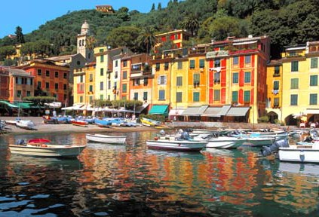

EXTENSION MILAN

Itinerary Day 1: Milan
On arrival in Milan, your local guide will meet you and take you by private transfer to the luxurious hotel, which is centrally located.

Day 2: Milan

Our first day in Milan includes a half day sightseeing tour of the city’s highlights. Fashion is big business and a big draw in Milan, from the extremely upscale stores of the Quadrilatero d'Oro to the more reasonably priced shops on Corso Buenos Aires. But there's plenty of other things to see and do including the ornate Duomo cathedral, the famous La Scala opera house, Naviglio Grande, Darsena, Conca di Viarenna, San Lorenzo Basilica and Columns, St Aquilino Chapel as well as the art museums, galleries and elegant palazzos. Leonardo da Vinci aficionados can book a viewing of “The Last Supper” and visit the Museo Nazionale della Scienza e Tecnica to see da Vinci's technical drawings and models. The afternoon and evening are completely free, allowing you to enjoy your final night in Italy. There is a very wide choice of restaurants, bistros and cafes to choose from as well as live music, opera and theatre. Make the most of it

Day 3: Milan/Como Lake/ Milan

Enjoy a full day sightseeing tour of Lake Como with a tour of the historic town and then a boat trip on the lake itself from where you can see the beautiful villas including Villa Olmo, Villa Erba and Villa d’Este. Return to Milan where the afternoon and evening are free for you to enjoy.

Day 4: Milan

Spend the morning as you choose before your private transfer to airport

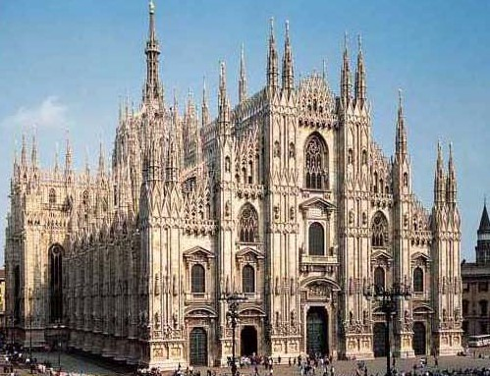

EXTENSION SICILY

Explore beautiful Taormina, overlooking the Ionian Sea, and its surroundings: the fertile lava‐flow country around Mount Etna and the Greek and Roman ruins of Syracuse.

Itinerary

Day 1: Taormina

You are met by your Travel Guru and transferred to your hotel in Taormina. This afternoon, join your driver‐guide for a private tour of Taormina. Visit the medieval village of Castelmol, founded on a crag high above the city. From here you have spectacular views over Taormina, the coast and Mount Etna. You may wish to toast your journey with a glass of locally produced almond wine.

Day 2: Taormina/Mount Etna/Taormina

This morning, while the skies are their clearest, head into the fertile lava‐ flow country of Mount Etna, Europe’s largest active volcano. Ascend 6,000 feet by road, admiring the stunning views as you go, and then by cable car up to the next level, where the landscape appears increasingly otherworldly. Return to Taormina in the afternoon; the remainder of the day is at your leisure.

Day 3: Taormina/Syracuse/Taormina

Spend a full day exploring Syracuse, a center of business and culture for 27 centuries. Visit the Greek Theater, one of the most important examples of theater architecture anywhere and a location of religious importance. The site was also a stone quarry and orchard. You can see the vast chambers dug out of the rock, including the “Dionyssos’ Ear,” a cave with amazing acoustic qualities. Nearby is the Roman Theater, a venue for entertainment. Continue to the charming neighborhood of Ortygia. This little island connected to the main city of Syracuse is a listed UNESCO World Heritage Site.

Day 4: Catania

En route to the airport and your departure flight, see Catania’s Piazza del Duomo, with its famous Fontana dell'Elefante (elephant fountain) and magnificent cathedral. You may catch a glimpse of the bustling fish and vegetable market that is located behind Fontana dell'Amenano fountain.

EXTENSION SARDINIA

A little less than 120 miles from the Italian mainland, Sardinia is a breathtaking Mediterranean island of rolling hills, dramatic mountains, soft sandy beaches and crystal clear waters. Its beautifully rugged scenery and unhurried pace make it the perfect destination for a relaxing beach holiday. riter D H Lawrence said Sardinia was ‘left outside of time and history’, and many ancient European traditions have survived in its festivals, language and architecture. Echoes of passing civilisations remain on the island ‐ traces of the Phoenicians, Carthaginians, Romans, Spanish and Tuscans, as well as Gothic and Baroque architecture.

Itinerary

Day 1: Sardinia

In Sardinia, considered to be the most spectacular of all the italian islands, you are met representative and privately transferred to your hotel.

Day 2 – 3 : Sardinia

You have a full days at leisure to relax on the beach, enjoy the facilities of your resort hotel or have a gorgeous night party in one of the numerous club of the Costa Smeralda.

Day 4: Sardinia

You are privately transferred to the airport, where you board your departure flight.

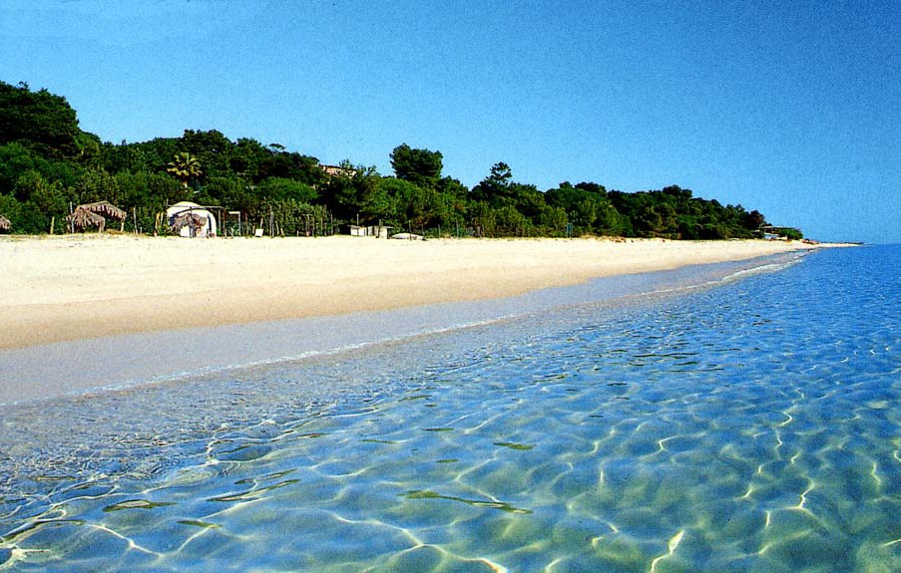

EXTENSION PARIS

The "City of Light" dazzles visitors with art treasures admired through the centuries, grandiose palaces satisfying regal egos and unrivaled shopping and dining options.

Itinerary

Day 1: Paris

Your Travel Guru meets you at the airport for your private‐vehicle transfer to your hotel. The remainder of your day is at leisure to begin exploring this fascinating city.

Day 2: Paris/Versailles/Paris

Explore the lavish palace of Versailles with your local specialist guide. Located south of Paris, Versailles is a glittering creation, famous for its vast landscaped gardens and opulent Hall of Mirrors. Your visit includes the magnificent State Apartments of the “Sun King” Louis XIV with some time at leisure to enjoy the gardens. Return to Paris, where the rest of the day is free to pursue your own interests.

Day 3: Paris

This morning, head to the Louvre with your local guide for a visit to its outstanding collections of art, including Venus de Milo, Ghirlandaio’s The Visitation and Leonardo da Vinci’s Mona Lisa. Alternatively, visit the Musée d'Orsay. Housed in a converted railway station, the museum’s main attraction is works by the Impressionists — Renoir, Sisley, Pissarro and Monet — and Post‐Impressionissts, including van Gogh and Cézanne.

Day 4: Paris

You are privately assisted to the airport for your departure flight

EXTENSION BARCELONA

Itinerary

Day 1: Barcelona

On arrival in Barcelona, your local guide will meet you and take you by private transfer to the luxurious hotel, which is centrally located, just a few metres from Passeig de Gràcia, one of the main avenues.

Day 2: Barcelona

Explore Barcelona on a comprehensive half day tour visiting the key sites in this cosmopolitan and bustling city. Highlights include Plaza Cataluna, the true heart of the city, the busy Via Laietana, The Cathedral and the famous Gothic Quarter. The rest of the day and the evening are free for you to relax and explore.

Day 3: Barcelona

Full day in Barcelona with enough to choose from whatever your interests. Keep it relaxed with a go‐as‐you‐please day of gentle meandering, interspersed with coffee shops, tapas bars, people watching and shopping, or turn up the dial and go all‐out on sightseeing and cultural immersion. A choice of additional excursions and sightseeing to complete your stay is available too.

Day 4: Barcelona

Spend the morning as you choose before your private transfer to airport

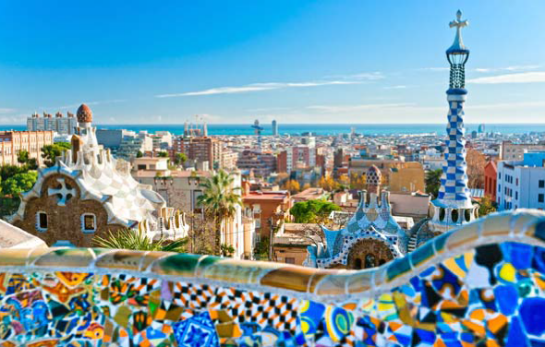

EXTENSION ISTANBUL

At the center of the Ottoman Empire with an imperial heritage spanning 1,700 years, Istanbul offers a treasure trove of history in its tangled streets.

Itinerary

Day 1: Istanbul

On arrival in Istanbul you are met and privately transferred to your old town hotel.

Day 2: Istanbul

Visit the Basilica Cistern, a marvel of civil engineering, and the Hagia Sophia, one of the greatest surviving examples of Byzantine architecture. Explore Topkapi Palace, once the massive center of the Ottoman government and court, and then stroll modern Istanbul’s cosmopolitan heart, the Pera District. Later this afternoon, privately cruise the Bosphorus.

Day 3: Istanbul

The master architect of the Ottoman Empire of the 16th century was Sinan, acclaimed by Frank Lloyd Wright as being the “master builder of all time.” Visit his dignified Suleymaniye Mosque, symbolizing the glory of the reign of Suleyman the Magnificent, and Rustem Pasha Mosque in the Blacksmiths Market. Visit the Spice Bazaar and the 3,500‐stall Grand Bazaar. If time permits, explore Dolmabahce Palace and its beautiful gardens.

Day 4: Istanbul

Transfer to the airport for your departure flight.

EXTENSION ATHENS

The gods of ancient Greece live on in myths, legends and the imposing structures built in their honor. Visit the Parthenon, the ancient, inhabited district of Plaka and the Temple of Poseidon during a family exploration of civilizations past. Take a private boat to Spinalonga and a ferry to Santorini, where you have time to relax and wander through Fira and the lovely town of Oia.

Itinerary

Day 1: Athens

Arrive in Athens, Greece’s capital and largest city.

Days 2: Athens

Explore symbolic monuments at the Acropolis, and discover the Panathenaic Stadium, National Archaeological Museum. Walk through the ancient, still‐ inhabited Plaka district.

Day 3: Athens

You are privately assisted to the airport for your departure flight

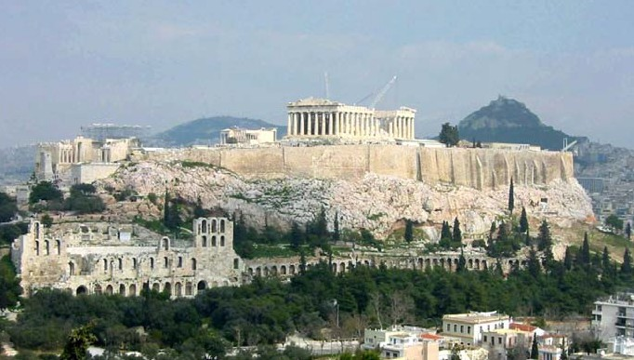

EXTENSION SANTORINI

White‐washed houses rest above the blue waters of the Aegean Sea, framing an island paradise. Relax and enjoy Greece's spectacular Santorini

Itinerary

Day 1: Santorini

In Santorini, considered to be the most spectacular of all the Greek islands, you are met by an English‐speaking representative and privately transferred to your hotel.

Day 2: Fira and Oia

On a panoramic sightseeing tour of the island with your private vehicle and local, you arrive in Fira, the capital, to visit a museum housing life‐size copies of all the frescoes found in the prehistoric site of Akrotiri. You may also walk to the edge of the caldera for spectacular views across the island before stopping in Oia, one of the prettiest villages in the Mediterranean. Your afternoon is at leisure.

Day 3: Santorini

You have a full day at leisure to relax and enjoy the facilities of your resort hotel.

Day 4: Santorini

You are privately transferred to the airport, where you board your departure flight.

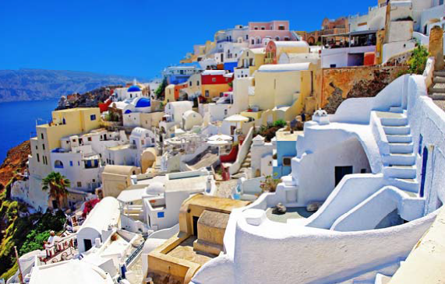

Ring the Bell.

Cristina Villa

info@creativeyogaretreat.com

Florence, Italy

Esplorando Travel/ Yogfgul
at Creative Yoga Retreat

+39 -3475350853
info@creativeyogaretreat.com

49 Negroli street Milan, Italy

